Enterprise

10% Profit goes on charitable donations.
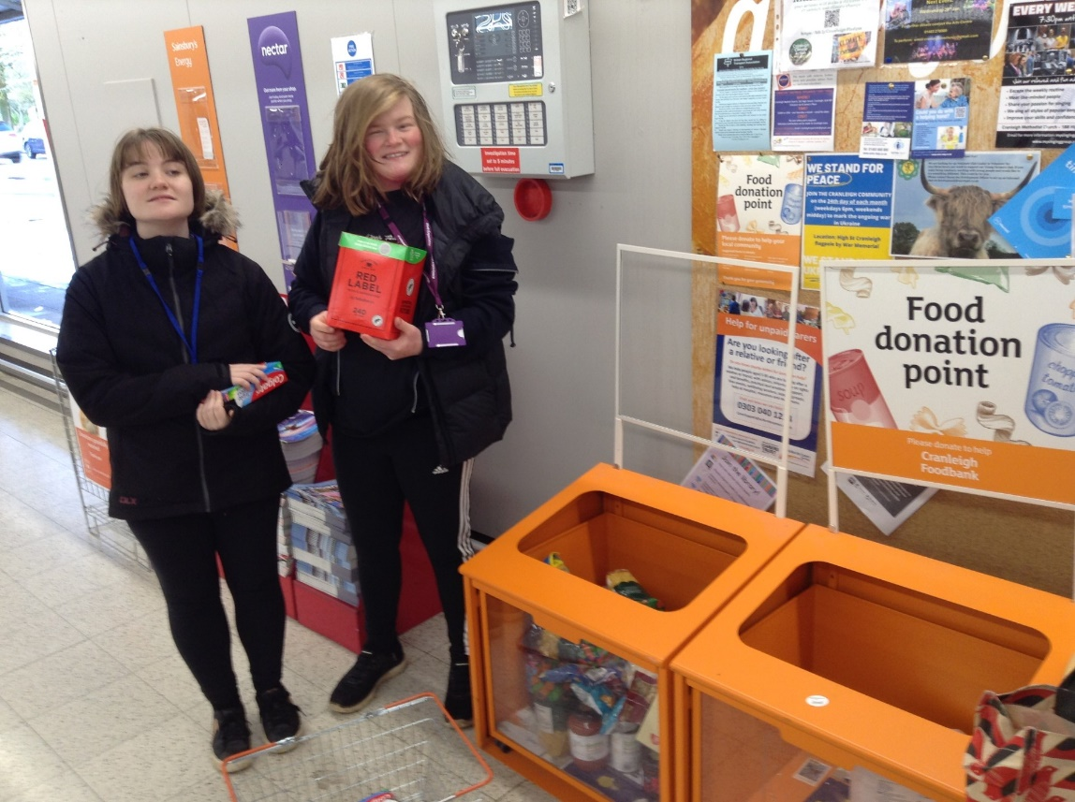

St. Nicolas' students, Olivia and Lexie, purchased several items from Sainsbury's, including toothpaste, tea, hoops, pasta, and rice. These items were then delivered to the orange collection boxes at Sainsbury’s. Both girls understood the meaning and purpose of this gesture.

31/01/25

