Catholic Social Teaching in Action
Practical
Cranleigh Foodbank
Preferential Option for the Poor, Solidarity, Participation

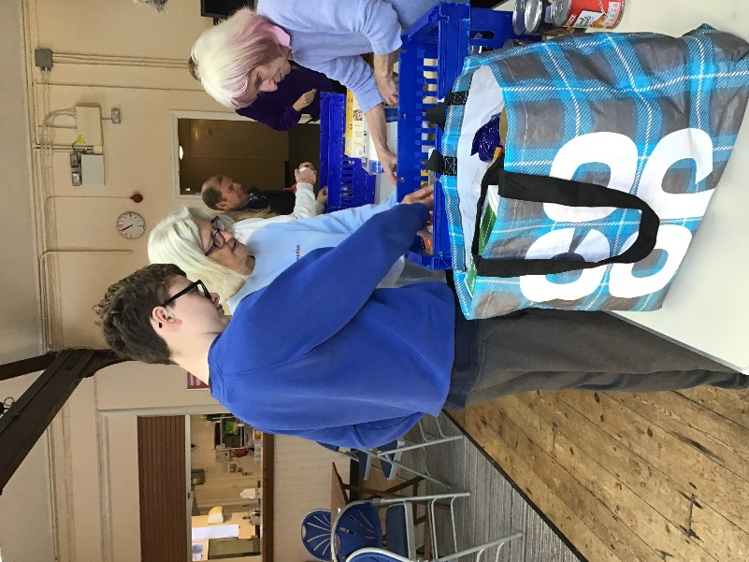
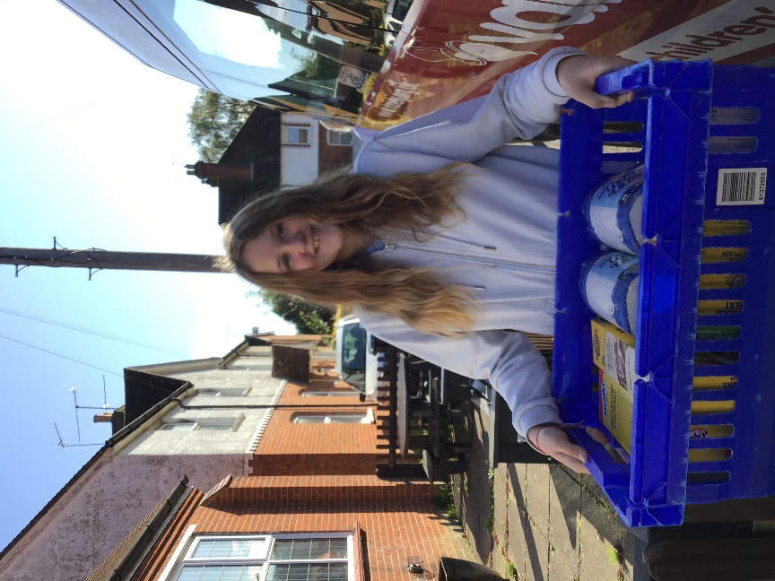

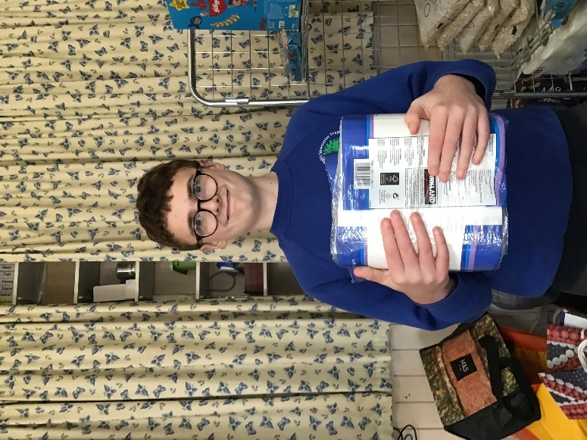

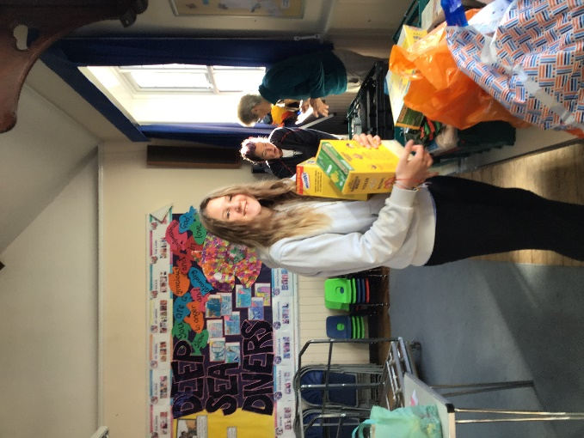

We will be extending our involvement with the Food bank, with our Enterprise Fortnight. Each class will use 10% of their profits to purchase food and household items to donate to the Foodbank.

Annual Secondary Pilgrimage
Human Dignity, Participation

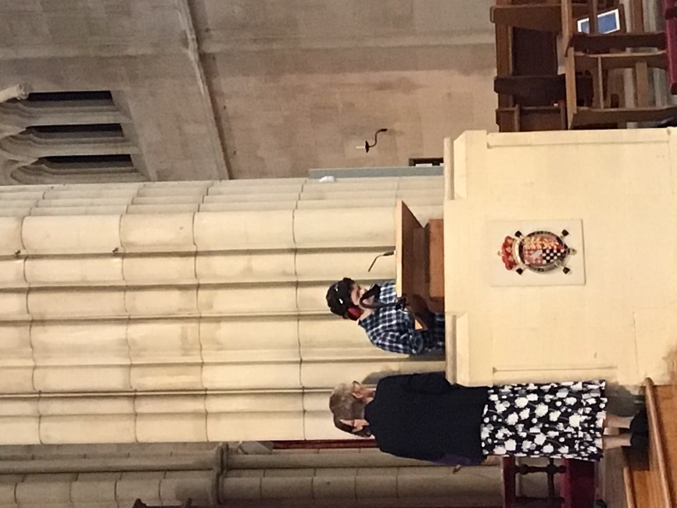
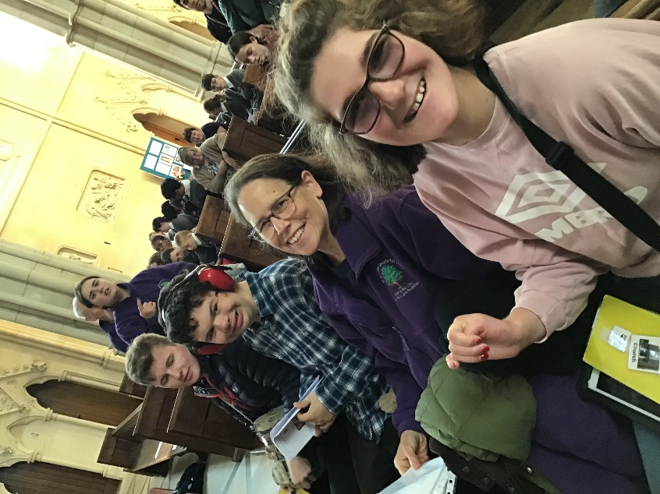

This is the bidding prayer, our student read at the Mass.
We pray for the Church, that we will be a shining example to all, in caring for our common home, sharing God’s gifts and recognising the worth and dignity of all God’s children.
Lord in your mercy…Hear our prayer

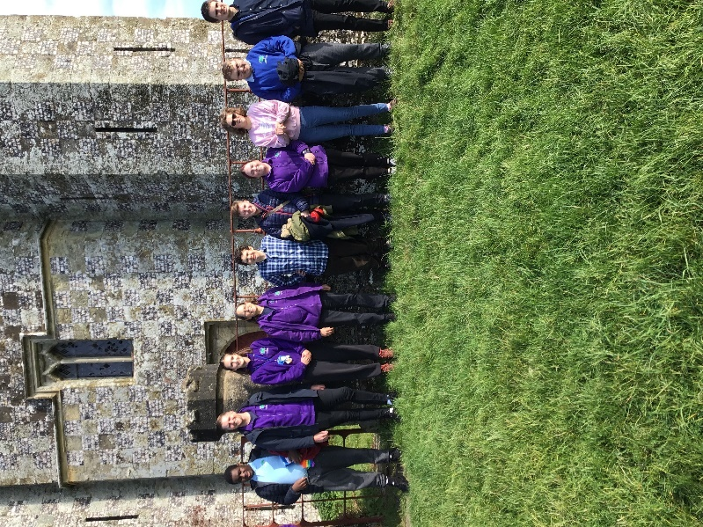

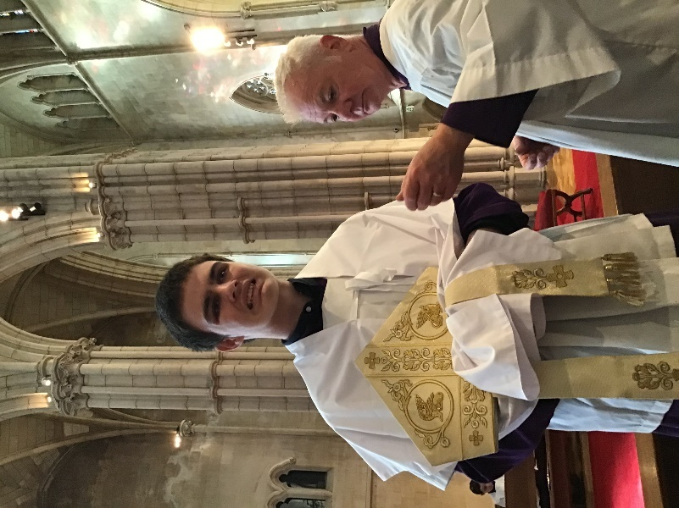

One of our students served Mass in the Cathedral for the first time.
Curriculum
Religious Education Directory, Branch 1, Creation and Covenant – Caring for our Common Home, Stewardship, Engaging with Laudato Si.
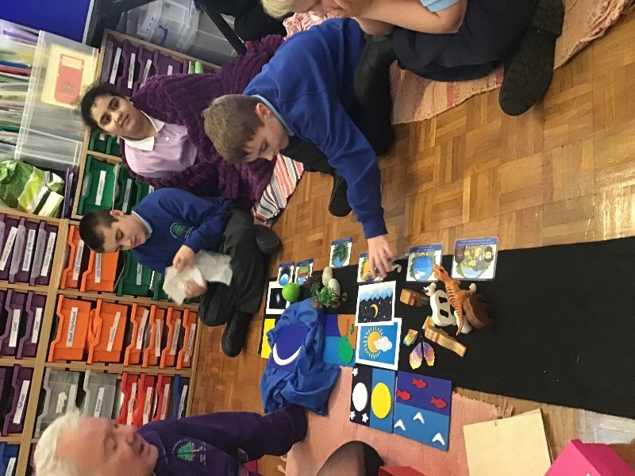
Engaging in a sensory re-telling of the First Creation Story, appreciating God’s goodness in all creation.

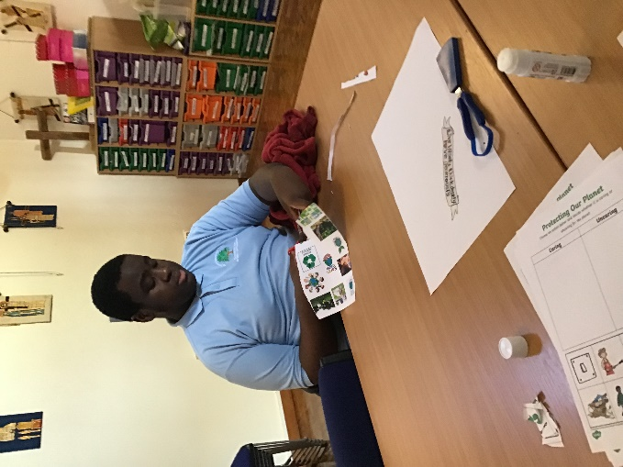

Links with science and geography – actions which show care for our planet.

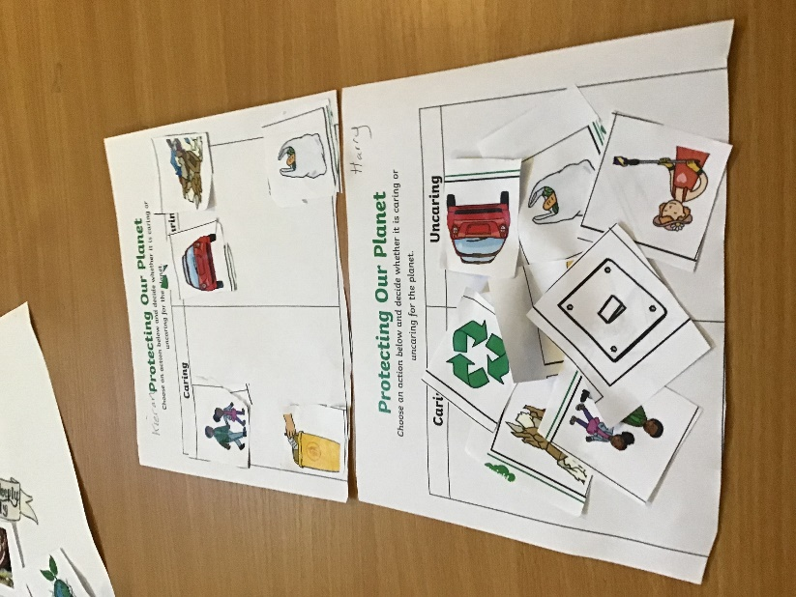
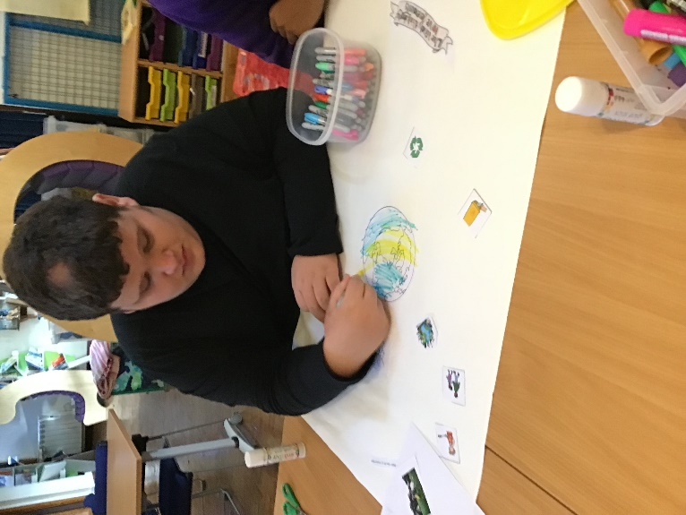

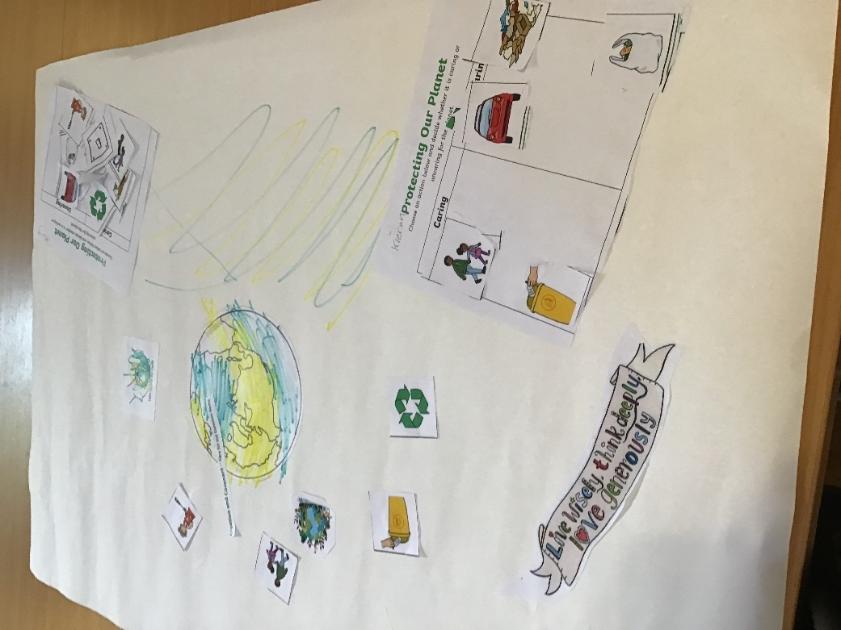
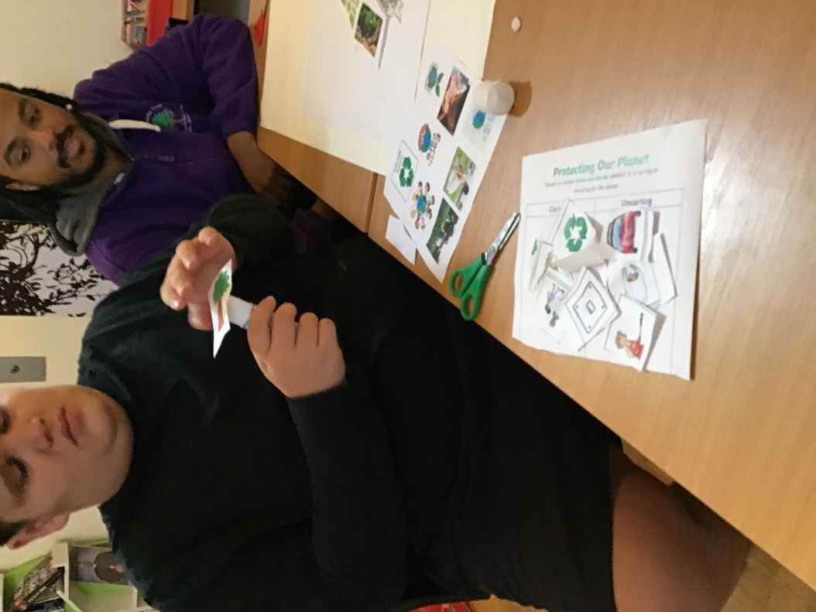
Making posters on ‘Caring for our Common Home’

Lesson Planning - Stewardship

Subject: RE
Date: w/c 14.10.24 Autumn 1 – Week 7
Pathway: Rainbows and Explorers
Topic: Creation and Covenant – Care for our Common Home
Learning Objective:
- Hear: Creation story
- Believe: God made the earth. He made humans to take care of it.

Please provide succinct instructions for all the activities.
Teaching Points:
God loves us and wants us to be joyful
God provides us with all we need to flourish
God is the source of all life

Starter: Revisit the creation story PPT: work/catholicity/creation to covenant/explorers and rainbows/creation story ppt
Main activity:
- Talk about how much God loves us and so we should love everyone and everything he made.
- Sing ‘Thank you God for the Gift of Creation’
- Talk about what we can do to care for the world.
- Complete the ‘protecting our planet’ sort activity.
- Select positive images of care for creation and create a poster using the ‘live wisely, think deeply, love generously.

Plenary: Can the students identify (point or say) what was made on different days in the story? Can they say/sign God loves the world, God loves me? Can they identify what are good and bad actions for the planet?
Resources: (please provide printed worksheets or web links or email them) Any other additional information (if applicable)

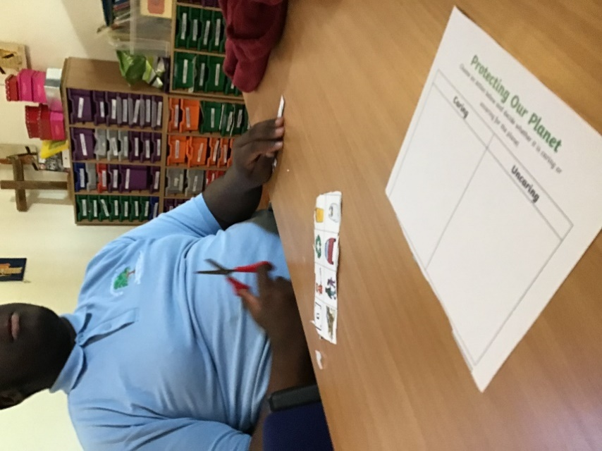
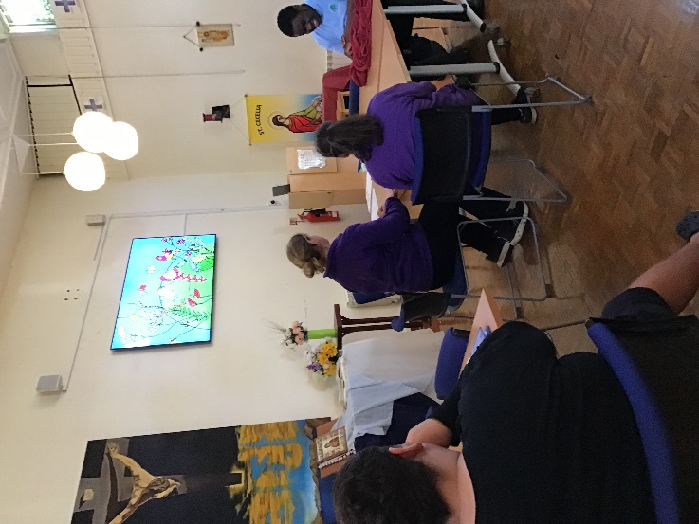

Watching CAFOD’s animation of Laudato Si

